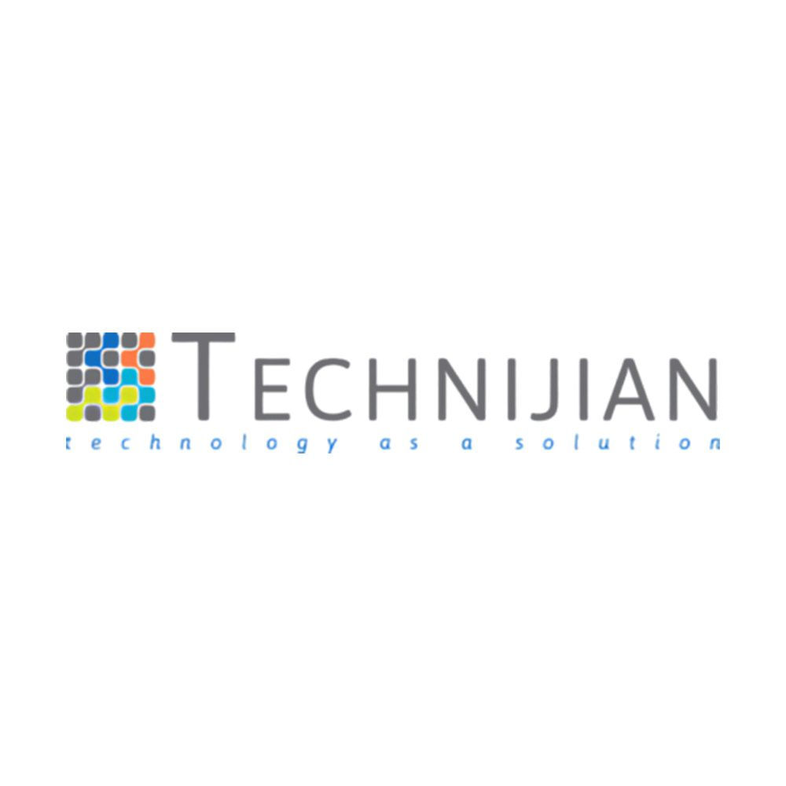 Technijian Chat.AI ENTERPRISE AI PLATFORM
4+ AI Providers | 32+ Endpoints | >60% Council Win Rate | 99.9% Uptime SLA

Secure, multi-model AI with collective intelligence, workflow automation, and enterprise governance.

KEY CAPABILITIES  Multi-Model AI  ✓ GPT-4o, Claude, Gemini + more — switch models mid-chat  ✓ Streaming responses with file attachments & analysis  ✓ Thread sharing with permissions, export & history  AI Council (Patent Pending)  ✓ 3-stage deliberation: Diverge → Converge → Synthesize  ✓ 3+ models per query, anonymized peer review  ✓ >30% hallucination reduction vs single models  Workflow & Knowledge  ✓ N8N workflow automation triggered from chat context  ✓ RAG with Weaviate, Pinecone, or Chroma vector stores  ✓ Custom assistants with REST/GraphQL/DB connectors  HOW IT WORKS  1. Deploy — Set up your tenant with Azure AD SSO in minutes  2. Configure — Choose AI models, set budgets, create assistants  3. Scale — Add users, workflows, and integrations as you grow | WHY CHAT.AI  ● Multi-provider — No vendor lock-in — OpenAI, Anthropic, Google, Azure  ● Cost control — Token-level metering with prepaid budgets & alerts  ● Enterprise security — Row-level isolation, full audit trail, HIPAA/SOC 2 ready  ● On-premise option — Deploy in your own infrastructure for data sovereignty  ● Council consensus — Patent-pending multi-agent deliberation  PRICING AT-A-GLANCE  Plan Price Users  Starter $299/mo 10  Growth $899/mo 50  Professional ★ $1,699/mo 100  Enterprise Custom 250+  SECURITY & COMPLIANCE  🔒 Azure AD SSO 🛡 Row-Level Security 📄 Audit Trail  🔐 Key Vault 🏣 HIPAA/SOC 2 Ready 🛠 RBAC Roles

Ready to see Chat.AI in action? Schedule a demo: RJain@technijian.com | 949.379.8500
© 2026 Technijian • 18 Technology Dr. Ste 141, Irvine CA 92618 • technijian.com

